AI-Simulated Market Research & A/B Testing Engine
Synthetic Persona-Based Campaign Testing Platform

https://www.kaggle.com/datasets/imakash3011/customer-personality-analysis/data

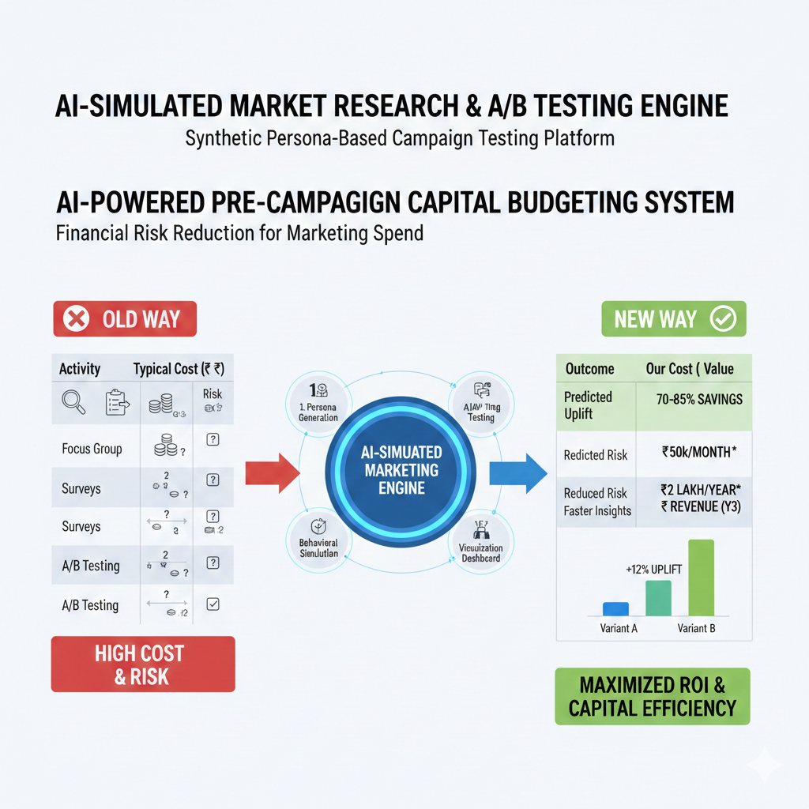

1. Executive Summary
Traditional marketing research methods such as Focus Group Discussions (FGDs), surveys, and live A/B testing are:
- Cost-intensive (participant incentives, logistics, moderation)
- Time-consuming
- Limited in sample size
- Prone to social desirability and moderator bias
This project proposes an AI-driven Synthetic Market Intelligence Platform that:
- Generates data-grounded customer personas
- Simulates persona-level reactions to product variations
- Predicts comparative acceptance and purchase probability
- Reduces cost and experimentation cycle time
- Provides pre-launch directional insights
This system is not designed to replace real-world testing but to act as a pre-screening decision intelligence layer to optimize marketing investments.

2. Problem Statement
When launching a new product or campaign, companies must answer:
- Which product variation will perform better?
- How will different customer segments respond?
- What objections might arise?
- What is the estimated conversion uplift?
Traditional methods are expensive and slow.
There is a need for a scalable, fast, low-cost simulation engine for concept testing.

3. Proposed Solution
We propose a Synthetic Persona-Based Simulation System that:
- Generates personas from real or synthetic datasets using clustering.
- Uses structured AI reasoning to simulate behavior.
- Compares A/B product variants.
- Aggregates results into actionable insights.
The system consists of four primary modules.

4. System Architecture
4.1 Persona Generation Engine
Input:
- Customer dataset (age, income, location, price sensitivity, loyalty, etc.)
Process:
- Standardize features
- Apply clustering (KMeans)
- Extract cluster centroids
- Convert centroids into structured persona profiles
Output:
Structured persona objects such as:
Persona ID: P1
Age Group: 25–35
Income Level: Upper Middle
Price Sensitivity: 0.7
Brand Loyalty: 0.4
Tech Adoption: High
Primary Motivation: Convenience
Personas are data-derived, not imagined.

4.2 Behavioral Simulation Engine
Each persona is used as structured input to a Large Language Model (LLM).
The LLM is constrained using:
- Low temperature (0–0.2)
- Strict response formatting
- Persona-attribute anchoring
- Limited token output
Standardized Output Format:
Purchase Probability (0-100):
Sentiment (Positive/Neutral/Negative):
Main Reason:
Primary Concern:
Confidence (Low/Medium/High):
This ensures:
- Deterministic outputs
- Reduced hallucination
- Structured quantification

4.3 A/B Testing Simulation Engine
For each persona:
- Evaluate Variant A
- Evaluate Variant B
Then compute:
- Average purchase probability
- Segment-level preference
- Overall predicted uplift
- Variance (uncertainty measure)
Weighted aggregation can be performed based on cluster sizes.

4.4 Visualization Dashboard
Built using Streamlit.
Displays:
- Persona distribution
- Variant comparison charts
- Predicted uplift
- Risk score
- Final recommendation

5. Technical Stack (Hackathon MVP)
Backend:
- Python
- Pandas
- NumPy
- Scikit-learn
AI Layer:
- OpenAI API (or similar LLM API)
- Structured prompting
Frontend:
- Streamlit
Visualization:
- Matplotlib or Plotly

6. MVP (Version 0 – Hackathon Version)
Objective:
Demonstrate working persona-based A/B simulation in one day.
Step-by-Step Build Plan
Step 1: Dataset Preparation
- Use Kaggle segmentation dataset OR
- Generate synthetic dataset (200 rows)
Fields:
- Age
- Income
- Location tier
- Price sensitivity
- Brand loyalty
- Category interest

Step 2: Persona Clustering
- Scale data
- Run KMeans (k=3 or 4)
- Assign cluster labels
- Extract centroid values
- Convert centroids into persona descriptions

Step 3: Structured LLM Prompting
Create template:
You are a consumer with the following characteristics:
[Persona attributes]
Evaluate this product:
[Product description]
Respond strictly in this format:
Purchase Probability:
Sentiment:
Main Reason:
Primary Concern:
Confidence:
Use low temperature for consistency.

Step 4: A/B Simulation Loop
For each persona:
- Evaluate Variant A
- Evaluate Variant B
Store responses in a dataframe.

Step 5: Aggregation
Compute:
- Mean purchase probability per variant
- Uplift percentage
- Segment-level comparison
- Confidence-weighted scoring

Step 6: Dashboard Deployment
Streamlit app:
Sidebar:
- Product A input
- Product B input
- Run Simulation button
Main panel:
- Persona table
- Comparison bar chart
- Recommendation summary

7. Hallucination Mitigation Strategy
- Structured output enforcement
- Deterministic temperature setting
- Persona grounding in clustered data
- Confidence threshold filtering
- Limited token generation
This transforms AI from creative generator to structured evaluator.

8. Validation Strategy
To strengthen credibility:
- Conduct small real-world survey (10–15 participants).
- Compare predicted winner vs actual winner.
- Calculate alignment percentage.
Even small validation improves robustness perception.

9. Risk & Limitations
- Cannot fully model irrational consumer behavior
- Dependent on quality of input data
- Does not replace large-scale live testing
- Limited generalization for entirely new product categories
This system is a decision-support engine, not a final authority.

10. Version Roadmap
Version 0 (Hackathon MVP)
- 3–4 personas
- A/B comparison
- Basic dashboard
- Structured AI scoring

Version 1 (Post-Hackathon Expansion)
Enhancements:
- Logistic regression calibration layer
- Monte Carlo uncertainty modeling
- Bias audit dashboard
- Historical benchmark anchoring
- Multi-agent interaction modeling
- Diffusion curve simulation
This evolves into a scalable enterprise marketing simulation platform.

11. Business Value Proposition
This system can:
- Reduce concept testing cost by 70–80%
- Reduce time-to-insight by 60–70%
- Improve marketing ROI through pre-screening
- Enable rapid experimentation
Positioning:
“AI-powered Synthetic Consumer Panel for Fast, Cost-Efficient Market Validation.”

12. Hackathon Execution Timeline (10 Hours)
Hour 1–2: Dataset + Clustering
Hour 3: Persona structuring
Hour 4–6: LLM simulation logic
Hour 7: Aggregation metrics
Hour 8–9: Streamlit dashboard
Hour 10: Testing + Pitch rehearsal

13. Conclusion
The AI-Simulated Market Research Engine offers a scalable, structured, and cost-efficient alternative to early-stage concept testing. By combining clustering-based persona generation with constrained AI simulation, the platform provides directional insights before committing to expensive real-world experimentation.
It is technically feasible within a one-day hackathon and scalable into a full enterprise solution.

🧠 MVP Technical Flow (Exact Architecture)
CSV Dataset
↓
Data Cleaning (pandas)
↓
Feature Scaling (StandardScaler)
↓
Clustering (KMeans)
↓
Extract Cluster Centroids
↓
Convert to Persona Profiles
↓
Loop Through Personas
↓
Send Structured Prompt to LLM
↓
Receive Structured Response
↓
Store in DataFrame
↓
Aggregate Metrics
↓
Visualize in Streamlit

⚙️ How You Actually Build It (Step-by-Step)
Step 1: Create or Use Dataset
Option A: Kaggle Customer Segmentation dataset
Option B: Create synthetic dataset with:
- Age
- Income
- Location tier
- Price sensitivity (0–1)
- Brand loyalty (0–1)
- Category interest score
You can generate 200 rows randomly in 5 minutes.

Step 2: Clustering Code Logic
- Scale features
- Run KMeans (k=3 or 4)
- Assign cluster labels
- Extract cluster averages
- Convert averages into persona descriptions
This gives you structured personas.

Step 3: Structured Prompt Engineering
Example prompt template:
You are a consumer persona with:
Age: {age}
Income: {income}
Price Sensitivity: {price}
Brand Loyalty: {loyalty}
Evaluate this product:
{product_description}
Respond strictly in this format:
Purchase Probability (0-100):
Sentiment:
Main Reason:
Primary Concern:
Confidence:
Important:
- Temperature = 0.1
- Max tokens limited
- No creative expansion
This reduces hallucination.

Step 4: A/B Simulation
Loop:
For each persona:
- Evaluate Variant A
- Evaluate Variant B
Store results:
| Persona | Variant | Purchase Probability | Sentiment | Confidence |
Then compute:
- Mean probability
- Uplift (B - A)
- Std deviation
- Winner variant

Step 5: Aggregation Logic
Weighted acceptance score:
If you assume equal segment size:
Simple average.
If you assume different segment sizes:
Weight by cluster size proportion.

Step 6: Streamlit Dashboard
Minimal UI structure:
Sidebar:
- Product A input
- Product B input
- Run Simulation button
Main:
- Persona table
- Bar chart: A vs B
- Recommendation box:
“Variant B predicted to outperform A by 12%”
Total dashboard time: 1–2 hours.

1️⃣ Financial Value Proposition
Traditional Market Research Costs:
Activity | Typical Cost (India estimate)
Focus Group (8–10 participants) | ₹75,000 – ₹2,00,000
Survey Panel (500 respondents) | ₹1.5 – ₹4 lakhs
A/B Testing (paid traffic + analysis) | ₹50,000+
Agency Research Study | ₹5–25 lakhs
Your AI system:
- One-time development cost
- Marginal cost per simulation ≈ API + compute
- Near-zero incremental cost per additional test
Core Financial Pitch:
Reduce pre-launch research cost by 70–85%.

2️⃣ Revenue Model Options
You need this for judges.
Model 1: SaaS Subscription
Tier-based pricing:
Starter
- ₹15,000/month
- 10 simulations
- 3 personas
Growth
- ₹50,000/month
- 100 simulations
- Advanced analytics
Enterprise
- Custom pricing
- API access
- Calibration + consulting
Recurring revenue model → high valuation multiple.

Model 2: Pay-Per-Simulation
- ₹3,000 per simulation
- ₹10,000 for full A/B testing report
- ₹25,000 for calibrated version
This works for startups.

Model 3: Hybrid (Recommended)
Subscription + premium analytics.

3️⃣ Cost Structure
3.1 Fixed Costs
Component | Estimated Cost
Initial Development | ₹1–2 lakhs
Cloud Hosting | ₹5,000/month
API Usage | Variable
Maintenance | ₹20,000/month

3.2 Variable Costs (Per Simulation)
Assume:
- 4 personas
- 2 variants
- 8 LLM calls
If each call costs ₹2–₹5:
Total ≈ ₹40 per full simulation.
You charge ₹3,000.
Gross margin ≈ 95%+
This is extremely attractive.

4️⃣ Break-Even Analysis
Assume:
- Monthly fixed cost: ₹50,000
- Contribution per client: ₹15,000
Break-even clients:
50,000 / 15,000 = ~4 clients
Very achievable.

5️⃣ ROI for Customers
If company normally spends ₹2 lakhs on concept testing
You charge ₹50,000 subscription
Savings = ₹1.5 lakhs per cycle
ROI = 3x
That is powerful in pitch.

6️⃣ Market Size (TAM, SAM, SOM)
TAM (Total Addressable Market)
Indian market research industry ≈ ₹10,000+ crores annually.
Even if you capture 1%:
₹100 crores opportunity.

SAM (Serviceable Market)
Digital-first startups + D2C brands + SMEs.
Thousands of companies.

SOM (Initial Target)
- 100 companies in first 2 years
- ₹50,000 average revenue
Revenue = ₹50 lakhs annually
Scalable.

7️⃣ Financial Projection (3-Year Model)
Year 1
- 20 clients
- ₹50,000 average revenue
- Revenue: ₹10 lakhs
Year 2
- 75 clients
- Revenue: ₹37.5 lakhs
Year 3
- 200 clients
- Revenue: ₹1 crore+
Gross margin >80%

8️⃣ Capital Budgeting Perspective (Since You Like Finance)
Initial Investment = ₹2 lakhs
Annual Cash Inflow (Year 2 onward) = ₹30 lakhs
NPV (even at 15% discount rate) → Highly positive
IRR likely >100%
This makes it venture-attractive.

9️⃣ Additional Monetization
- Data benchmarking reports
- Industry-specific persona packs
- API licensing to agencies
- White-label solution
- Consulting + customization

🔟 Risk Assessment (Financial)
Risk | Mitigation
Low adoption | Freemium model
LLM cost increase | Optimize prompt tokens
Model inaccuracy | Calibration layer
Competition | Proprietary persona dataset

1️⃣1️⃣ Advanced Financial Angle (To Impress Judges)
You can integrate:
Marketing Budget Optimizer
Use predicted uplift to calculate:
Expected Revenue Uplift =
Conversion Rate × Traffic × Margin
Then:
NPV of Campaign =
Future Cash Flows discounted at WACC
Now your tool becomes:
AI-powered Pre-Campaign Capital Budgeting System
That is extremely strong.

1️⃣2️⃣ How to Present Financial Slide
Structure:
- Current Cost Problem
- Our Cost
- Margin Structure
- Break-even
- 3-Year Revenue Projection
- Scalability Argument

Strategic Insight
Judges will value this more if you position it as:
“Financial risk-reduction tool for marketing spend.”
Not just:
“AI focus group replacement.”

